Contracts and permits

The Target store located in Waterloo is going to be about 122,692-square-foot. We will need different types of permits because they ensure that construction within our municipality meets with standards set out in the Ontario Building Code. In addition, building permits are necessary to guarantee that other applicable laws such as zoning by-laws, site plan control by-laws etc. are complied with (London Canada, 2012)

These are a list of contracts and permits we will be submitting for out Target store opening in Waterloo, Ontario for August 17th, 2013.

- Building permit, which will set out standards for the design and construction of buildings to meet objectives such as health, safety, fire protection, shipping and receiving docks as well as accessibility.
- Local zoning by-law permits as well as other planning controls on buildings
- Any other application legislation including those that fall under the Environmental Protection Act.
- Contracts for employees, what the requirements are and how wages will be paid out (i.e. how people can get a raise, take a leave-of-absence, maternity leave etc.)
- Managerial contracts discussing what the roles and requirements are of each manager on duty
- Contracts with each supplier outlining how and when supplies will be processed and ordered
- Contracts with Ontario Hydro for Electrical and Hydro requirements of the store
The city of Waterloo has set dates on the type of permit and the cut off date for completed submissions. The dates are as follows:
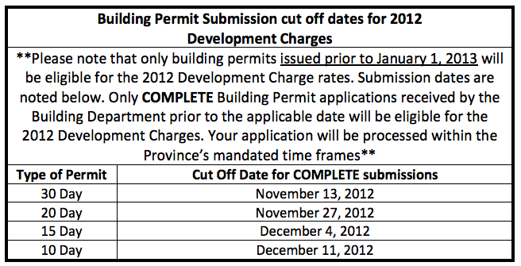(The City of Waterloo, 2012)

