Jennifer Paul
Media Assessment— Region of Waterloo

Executive Summary
This report outlines the media assessment for the Region of Waterloo. The region includes Waterloo, Kitchener, St. Jacobs, New Hamburg, Baden, Elmira and Cambridge. The media assessment includes a media map of the region and all television, radio and print sources within the Waterloo region. Waterloo has a growing economy; Kitchener has grown immensely over the past few years. Kitchener has brought in about 14,000 new residents whereas Waterloo has only brought in about 1000. The media outlets are scattered throughout the region with heavy standpoints in both Waterloo and Kitchener. This assessment indicates media operations and understanding of the institutions media relations. Institutional assessments have been made for three media outlets within the Waterloo region.
These assessments include The Observer, Radio Waterloo Inc., and CJIQ FM. Each of the media outlets have been assessed thoroughly with emphasis on important factors and information regarding the structure of the organization, staff, ownership, circulation, audience, advertisers, content, special features and notable employees.

Geographic Media Mapping

Television
1. CTV Kitchener
2. Rogers TV
3. Global (CIII-DT)
4. CTV (CKCO-DT)
5. TV Ontario (CICD-DT-28)
Print
Newspapers
1. Waterloo Region Record
2. Kitchener Post
3. Waterloo Chronicle
4. Cambridge Times
5. Elmira Independent
6. The Observer
7. New Hamburg Independent
Magazines
8. Visitor Guide
9. Exchange Magazine
Radio
1. CKGL 570 AM
2. CJIQ FM 88.3FM
3. OBLA FM 89.1FM
4. CKBT FM 91.5FM
5. CJTW FM 94.3FM
6. CHYM FM 96.7FM
7. CKWR FM 98.5FM
8. CKKW FM 99.5FM
9. CKMS FM 100.3FM
10. CKAV FM8 102.5FM
11. CFCA FM 105.3FM
12. CJDV FM 107.5FM

RIM Park

Mennonite Population
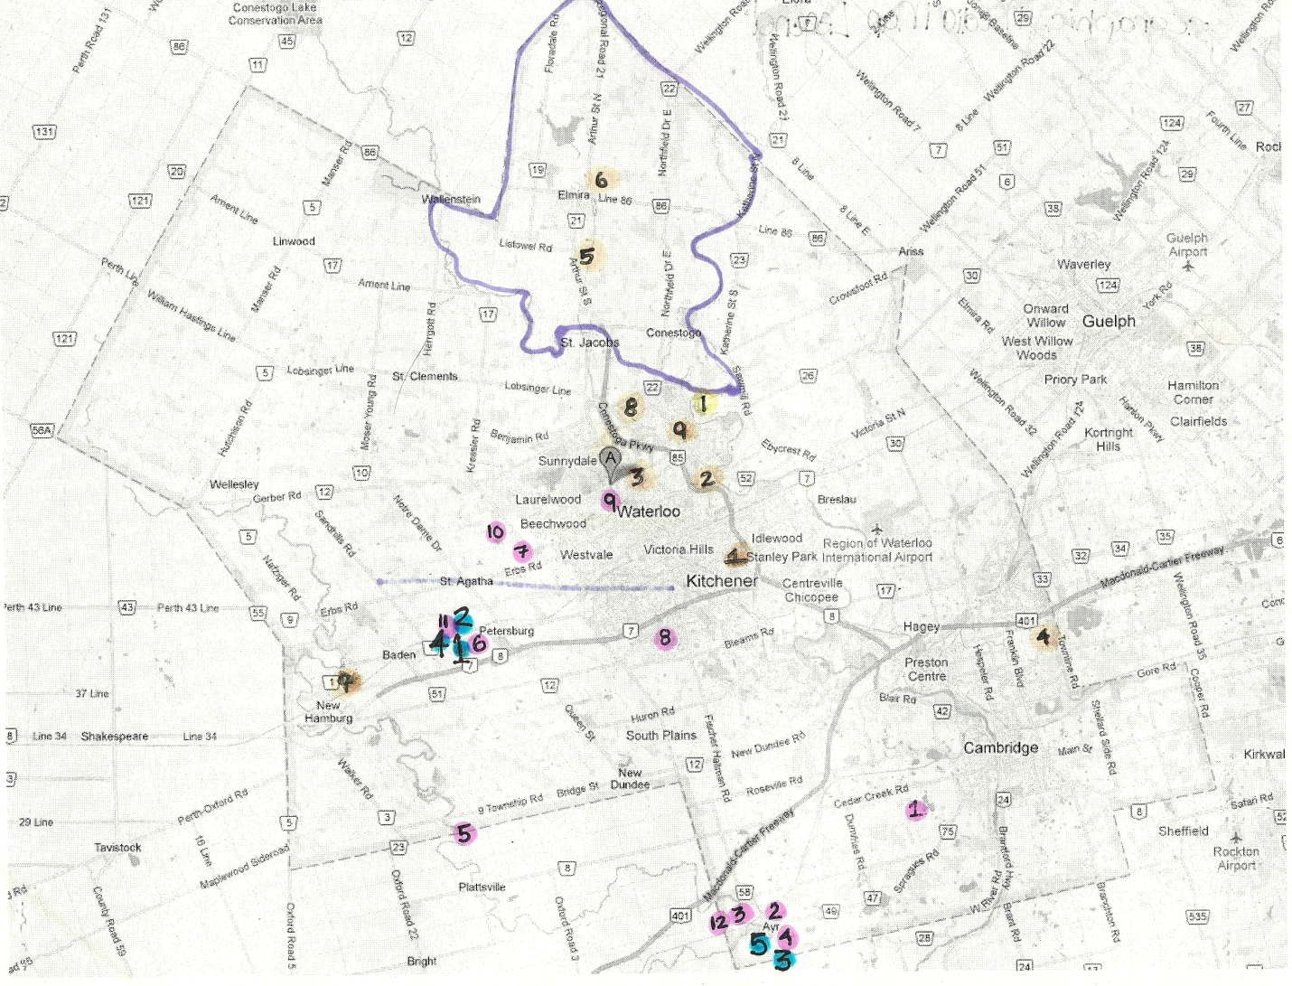

Institutional Assessment
The Observer
The Observer is the largest distributed newspaper in Woolwhich & Wellesley Township. It is a community paper. It began publishing in 1996. Elmira natives Joe Merlihan who is the publisher, and his brother Pat Merihan who is the newspaper’s production manager were the ones to launch the newspaper.
Ownership Structure
The Observer is a member of the Canadian Community Newspapers Association (CCNA), the Ontario Community Newspapers Association (OCNA) (it is a regional association), and the Ontario Press Council (Observer Philosophy, 2013). Newspapers Canada is a joint initiative of the Canadian Newspaper Association and the Canadian Community Newspapers Association.
Both The Canadian Newspaper Association (CAN) and the Canadian Community Newspapers Association (CCNA) are two separate organizations that have partnered together to create a solid industry voice for all newspapers in Canada. Combined, the two associations represent over 830 daily, weekly, and community newspapers in every province and territory in Canada (Newspapers Canada, 2013). Both organizations are now co-managed by a single CEO. They still remain governed by two separate boards of directors so that they can reserve the uniqueness of the programs and services that they offer to each one of their members. By combining resources and collaborating on a variety of different projects Newspapers Canada provides more relevant services to all newspaper members, while also increasing the profile and effectiveness of the newspaper industry in Canada (Newspapers Canada, 2013).
Today, the primary role of Newspapers Canada is to represent the needs of CNA and CCNA members in three major areas:
· Public Affairs
· Marketing
· Member Services (Newspapers Canada, 2013)
The Ontario Press council ensures that journalistic and ethical standards are being met on behalf of the public and the press. They also defend the democratic right of free speech and freedom of the press.
Staff Organization
The observer is co-managed under the Newspapers Canada brand. Its own board of directors governs each association. Each board is comprised of publishers and senior executives that take into consideration the association’s membership, they represent the array of interests that the association’s membership brings. The role of the boards is to identify priorities, approve a budget, develop policy, oversee the committees, and monitor the associations' directions and performance (Newspapers Canada, 2013). Members from the board of directors chair the committees; it includes sales, editorial, columnists and production.
Circulation/reach
The circulation of the newspaper is 14,741, which was conducted by Canadian Media. Their print run is 15, 300. The publication day is Fridays, and they do home deliveries to Woolwich Township, Wellesley Township and Waterloo Neighbourhoods (Observer Media Kit, 2010).
The cost to run a thousand newspapers is $50. There are three flyer zones that the newspaper reaches. Zone one consists on 4,100 newspapers, zone two consists of 6,100 newspapers, and zone three consists of 4,000 newspapers. There are other areas that are of interest but have yet to be distributed to.
Target audience
The paper thrives on the significance of being a community-based newspaper. The audience is very community based. The paper has a lot of in town assessment and criteria. The people who read the paper are those who live in the township. They would be the ones who are involved within the community and like to be up to date on any happenings that occur around them. The target age range could be anywhere from 14 years of age and older.
Major Advertisers
The major advertisers that repeatedly show up in the newspapers are St. Jacobs Farmers Market, Whoolwhich TotalHealth Pharmacy, Elmira Wellness Centre, Twin City Minor Hockey Association, Remax, as well as BMO. Most of the advertisers are in town and community based as well.
Content Organization
The content in the newspaper is organization through sections. Each section is devoted to a specific topic of interest of its members. The newspaper starts off with a news section; this is critical content for the community, as well as relevant content. It then divulges into group related content that includes the Comment section, sports section, News Business and/or Venture section, Feature stories (for example Wedding Feature), The Arts section, Classifieds, Real Estate, and finally ends with a Living Here section.
Special features
A special feature that they offer is online classified that you are no able to find or access from the deliverable newspaper.
Notable employees
Bill Sones is a columnist who writes the Strange but True column in The Observer. He is a freelance journalist who has been very successful in his career. He has appeared in Reader’s Digest, Discover, Family Circle, Good Housekeeping, Boy’s Life and many more. Some of his work has even spread to the New York Time Syndicate as well as the Los Angeles Times Syndicate.
Owen Roverts is a columnist who writes a column called Food for thought. He is the director of research communication for the University of Guelph, he also teaches there and serves as an assistant faculty member. Owen has been involved in journalism for three decades. The Ontario Community Newspapers’ Association named Owen one of Ontario’s top columnists twice. He is currently the secretary general of the International Federation of Agricultural Journalists after being past president.

Radio Waterloo Inc.
SoundsFM is a non-profit volunteer based corporation. Its primary purpose is to maintain, equip and operate a CRTC licensed FM radio station. SoundFM is a community based radio station and is committed to training community members and students in the techniques of broadcasting (GetInvolved, 2012). The station is dedicated to serving the programming needs of people within the community. SoundFM draws from the rich variety of skills and perspectives that Waterloo's communities have to offer in order to create quality programming and better serve the community itself (GetInvolved, 2012). The programming being broadcasted is different then regular radio programming on commercial or public airwaves. SoundFM is dedicated to introducing their listeners to new and unheard perspectives. It is a radio station for the people, by the people.
Ownership Structure
A board of directors that is made up of students and community members, all of which are volunteers, governs the station. It runs as a co-operative organization, which means that the people who use its services own it. The students of the University of Waterloo once funded it, it was paid for by each student as a fee comprised in their tuition but it no longer operates through the university.
Staff Organization
SoundFM is managed by a programmers co-operative and supported by volunteer staff and Board of Directors. Unfortunately the organizational structure needs to be restored. It is a very lenient dictatorship and people do not take full responsibilities in their roles at the station. This is something that is in the process of being structured.
President: Dan Kellar
Vice-President: Mark Ceisluk
Treasurer: Nat Persaud
Secretary: Sam Tisi
Member at Large: Carlo Farruggio
Member at Large: Jordan Dorans (soundfm.ca, 2011)
Circulation/Reach
The station reaches the communities from Waterloo to Oshweken Ontario.
Target Audience
The station targets audiences that live in the Waterloo community, as well as individuals who are optimistic and willing to understand new perspectives. It has a lot of student involvement, as well as community members. It tries to attract local and perspective talent through its programming.
Major Advertisers
At the moment SoundFM does not have major advertisers, they are currently working on building relationships with smaller organizations throughout the city to endorse their services.
Content Organization
SoundFM will not promote any single religious or political philosophy. They keep an open mind about all subjects and give people the opportunity to speak their minds without offending anyone. SoundFM encourages the appreciation of each viewpoint by nature of the station's openness and accessibility (soundfm.ca, 2011). All content must follow CRTC regulations. SoundFM is committed to reflecting the true diversity of the Waterloo community, and is committed to providing access to the airwaves for groups and individuals who have little or no access to mainstream media (soundfm.ca, 2011).
Special Features
The special features of the station are community concerns, events and activities throughout the community are emphasized. The station also gives people the opportunity to drop off their own CD with the possibility that the songs will make it on air.
Notable employees
Dan Kellar is president and he spends most of his time at the station running the organizational structure. People come and go so quickly and it is his responsibility to make sure that all requirements are met regulated by the CRTC.

CJIQ FM 88.3
This is Conestoga College’s very own radio station. The station is classified as Instructional by the CRTC (Conestoga, 2010).
Ownership Structure
CJIO FM is partnered with Conestoga College. It is also associated with Conestoga College Alumni and Bloom. Bloom is an upscale dinning experience located at the Waterloo campus. It is a full service dining room, and hospitality and culinary students run the dining room as part of their curriculum.
Staff Organization
The program is run by both journalism and broadcast students, it is used as a lab for those who are involved in the programs. As well, dedicated teachers, coordinators and volunteer’s assist in the organizational structure of the on campus radio station.
Circulation/ Reach
The station reaches all Conestoga College students at each campus. They include Doon, Waterloo, Guelph and Cambridge. The reach of the station runs from Kitchener to Paris, Ontario.
Target Audience
The target audience for the station is generally the student community. These people would fall between the ages of 18-34, generally speaking. It also draws attention to new rock fans. 88-3 CJIQ programs a New Rock format. The tempo of the station is definitely up-tempo and skewed towards the 18-34 demographic (Conestoga, 2010). The weekend features music of different genres.
Major Advertisers
The major advertisers of the station are Koodo, Sullivan Automotive, Traces Screen Printing, Drive Sober and mainly Bloom.
Content Organization
The station has many different shows; every weekend different shows are aired with different genres of music being played. The station provides students with variety. It provides students with information regarding the school and school issues that may arise. It is about content that is applicable to the student body as a whole.

Special Features
The station offers features like giving students a voice on the airwaves. With it be being catered to students it offers different perspectives and outcomes to the target audience.
Notable Employees
Students that are integrated into the station through their field of study, those individuals are putting forward their best efforts and giving the student bodies a voice.
Furthermore, each assessment outlines notable information about the media institution. Each media institution has responsibilities and requirements that need to be met. Each outlet has a target audience they need to cater to, and each institution has further information or improvements that can be made. The Waterloo region is accessible to media institutions because of the number of individuals living the surrounding area. With three universities and multiple college campuses the region is ideal for any sort of media institution to become significant. The region has a history of small communities and this may be why so many media outlets have flourished so far. People are dedicated and loyal when it comes to what they are familiar with.
Request for Information
1. Media Kits being more accessible for all institutions
2. Labeling advertisers and associated institutions information on their own webpage
3. Radio Waterloo Inc. to have more information posted on their website. It is very informal and outdated.

References

Cathedral Communication Inc. Observer philosophy. (2013). Retrieved from
http://observerxtra.com/2/about-2/
Conestoga College. (2010). Cjiq- about us. Retrieved from
http://www.cjiq.fm/about.jsp
Get Involved.ca. (2012). Radio waterloo inc.. Retrieved from
http://www.getinvolved.ca/profile/radio-waterloo-inc/
Newspapers Canada. (2013). About us. Retrieved from
http://www.newspaperscanada.ca/about-us
Newspapers Canada. (2013). Board Of Directors. Retrieved from
http://www.newspaperscanada.ca/about-us/boards-directors

